# Shift-Left Approach

## 1-What is Shift-Left Approach

**# Source**: **Chatgpt (GPT-5-Standard) at [8/14/2025]**

The **Shift-Left Approach** in software development and testing means **moving testing and quality activities earlier ("to the left") in the development lifecycle** — so issues are found and fixed **as early as possible**.

## 2-Why “Shift Left”?

**# Source**: **Chatgpt (GPT-5-Standard) at [8/14/2025]**

* In a traditional (Waterfall) process, testing happens at the **end** — after coding is complete.
* This often means:  
  + Bugs are found late (when they’re more expensive to fix).
  + Release schedules are delayed.
  + Quality problems escape into production.
* By **shifting testing left** (earlier), you detect and fix problems while they’re still small and cheap.

## 3-Core Idea

**# Source**: **Chatgpt (GPT-5-Standard) at [8/14/2025]**

* Don’t wait until the end to verify quality.
* Start quality checks **from the very first stages**: requirements, design, coding.
* Testing becomes **continuous** rather than a separate phase.

## 4-How It Works

**# Source**: **Chatgpt (GPT-5-Standard) at [8/14/2025]**

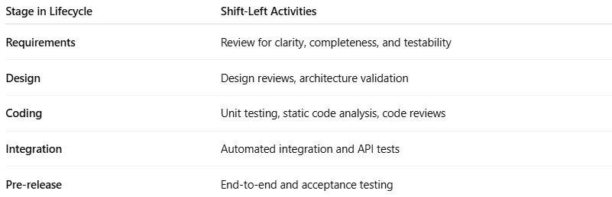

| **Stage in Lifecycle** | **Shift-Left Activities** |
| --- | --- |
| **Requirements** | Review for clarity, completeness, and testability |
| **Design** | Design reviews, architecture validation |
| **Coding** | Unit testing, static code analysis, code reviews |
| **Integration** | Automated integration and API tests |
| **Pre-release** | End-to-end and acceptance testing |

## 5-Benefits

**# Source**: **Chatgpt (GPT-5-Standard) at [8/14/2025]**

1. **Early bug detection** → Fixing a bug found during coding is far cheaper than in production.
2. **Faster feedback** → Developers know quickly if they broke something.
3. **Better quality** → Continuous quality assurance at each stage.
4. **Reduced costs** → Early fixes cost less time and money.

## 6-Example

**# Source**: **Chatgpt (GPT-5-Standard) at [8/14/2025]**

**Without Shift Left (Traditional)**:

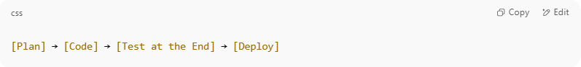

[Plan] → [Code] → [Test at the End] → [Deploy]

Bugs found here are late, expensive, and risk deadlines.

**With Shift Left**:

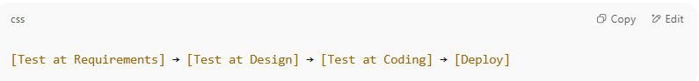

[Test at Requirements] → [Test at Design] → [Test at Coding] → [Deploy]

Bugs are found and fixed earlier, reducing risk.

## 7-In DevOps & Agile

**# Source**: **Chatgpt (GPT-5-Standard) at [8/14/2025]**

* Shift-left is implemented with **automated testing in CI/CD pipelines**.
* Includes unit tests, static analysis, API tests, and early integration tests — all run *before* deployment stages.